Purposes and Methods of Cub Scouting
The Cub Scouting program has 10 purposes related to the overall mission of the Boy Scouts of America – to build character, learn citizenship, and develop personal fitness:
Every Cub Scouting activity should help fulfill one of these purposes. When considering a new activity, ask which purpose or purposes it supports. Not everything in Cub Scouting has to be serious – far from it! Silly songs, energetic games, and yummy snacks all have their place in the program.
The Methods of Cub Scouting
To accomplish its purposes and achieve the overall goals of building character, learning citizenship, and developing personal fitness, Cub Scouting uses seven methods:
1. Living the Ideals
Cub Scouting’s values are embedded in the Cub Scout Promise , the Law of the Pack , the Cub Scout motto , and the Cub Scout sign , handshake , and salute. These practices help establish and reinforce the program’s values in youth and the leaders who guide them.
2. Belonging to a Den
The den—a group of six to eight youth who are about the same age—is the place where Cub Scouting starts. In the den, Cub Scouts develop new skills and interests, they practice sportsmanship and good citizenship, and they learn to do their best, not just for themselves but for the den as well.
3. Using Advancement
Recognition is important to boys. The advancement plan provides fun for the youth, gives them a sense of personal achievement as they earn badges, and strengthens family understanding as adult family members and their den leader work with him/her on advancement projects.
4. Involving Family and Home
Whether a Cub Scout lives with two parents or one, a foster family, or other relatives, his/her family is an important part of Cub Scouting. Parents and adult family members provide leadership and support for Cub Scouting and help ensure that the youth have a good experience in the program.
5. Participating in Activities
Cub Scouts participate in a huge array of activities, including games, projects, skits, stunts, songs, outdoor activities, trips and service projects. Besides being fun, these activities offer opportunities for growth, achievement, and family involvement.
6. Serving Home and Neighborhood
Cub Scouting focuses on the home and neighborhood. It helps children strengthen connections to their local communities, which in turn support the childs growth and development.
7. Wearing the Uniform
Cub Scout uniforms serve a dual purpose, demonstrating membership in the group (everyone is dressed alike) and individual achievement (youth wear the badges they’ve earned). Wearing the uniform to meetings and activities also encourages a neat appearance, a sense of belonging, and good behavior.
8. Making Character Connections
Throughout the program, leaders learn to identify and use character lessons in activities so youth can learn to know, commit, and practice the 12 core values of Cub Scouting. Character Connections are included in all the methods of Cub Scouting and are the program themes for monthly pack meetings.

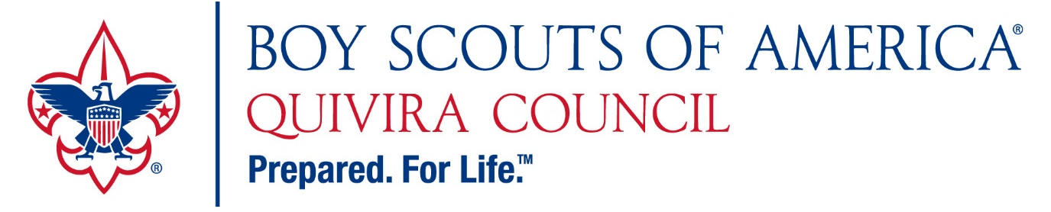
What does Scouting do?
Character Education – Courteous, Kind, Obedient… Better students, better citizens.
Accessibility – Scholarships – Anyone can be a Scout.
Families
Bringing families together – program is family oriented and creates “family time”.
Now more than ever with the inclusion of girls!
Families mentoring families.
Engages “fringe” parents – every parent is expected to take part.
97% of all adult Scouters say the program helped them be better parents/spouses.
Youth Wellness
All inclusive, built in sense of belonging.
Self-reliance, confidence.
Scouts don’t fail – they work until they succeed. Resulting in better grades and more success in all life areas.
The program gives children new experiences on a consistent basis.
Much of the program is designed to be done “outside” – no screens.
Poverty – Beating generational poverty by connecting lower income families with middle income families.
What does the Cub Scouting look like?
- Weekly or biweekly meetings.
- Scout handbooks guide parents and leaders.
- The program recognizes hard work and accomplishment.
- The program provides opportunity to try new things, build self-confidence and reinforce ethical standards.
The direct connection:
- Attendance – Trustworthy, Helpful, Friendly
- Behavior – Courteous, Kind, Obedient, Cheerful, Friendly
- Academic Performance – Cub Scout Adventures and Scouts BSA Merit Badges

“Do Your Best!” - Scouts Succeed.

For more information:
Local Scouting Council: www.quivira.org National BSA: BeAScout.org

